Connecting Starred Sample IDs with TA/TIC data – deviations from expected TA/TIC and TA/Sal
Sample ID’s below were flagged in the QAQC process: they are all surface samples (<100m, colour in plot corresponds to depth), and most are within the TCA/ADDOCS region of interest (ROIs), identified as having high productivity (Phaeocystis bloom), or are samples from the Labrador and Greenland shelf regions.

515657 AR7W12 4 m? higher lower down
515760 AR7W15 50m?
515848 NROI001 30 m (low ta)
515895 NROI002 20m (low ta)
What about NROI03? Lower than 1,2, and 4, but should still see this deviation?
516020 NROI004 25 m (high TIC, low ta)
516427 CROI003 40 m – low here
516491 AR7W07 30 m – low here, should be 08?
516536 AR7W04 20m
516604 SROI30 m – TA only
516607 SROI 10m – TA only
516608 SROI 3 m - TA only
516551 AR7W03 100m – low ta and tic
Based on the map we should see deviations at:

Plot TA/TIC ratio: change in TA with change in TIC should be 1.13 from theory (Hiscock and Millero 2006)
Link this to the chl a
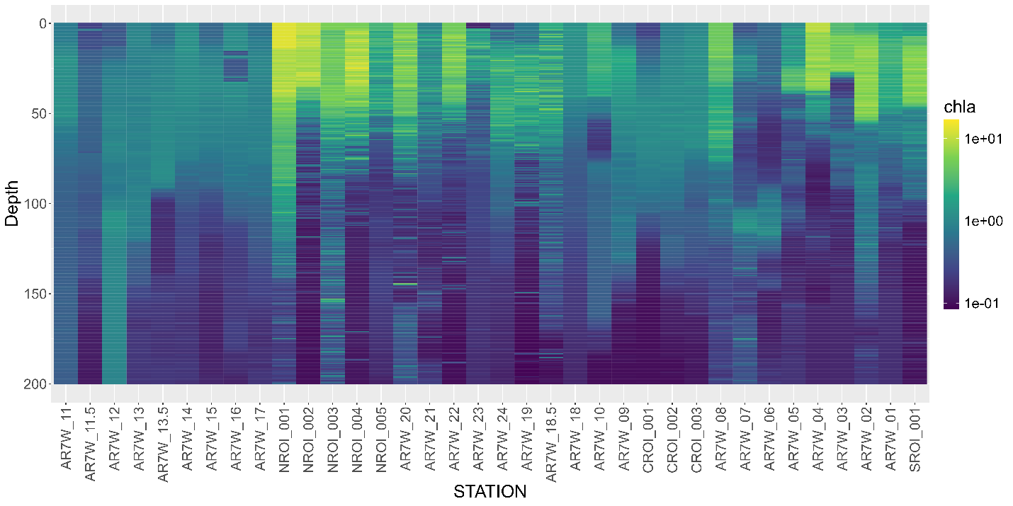

Figure. Chl-a concentrations for station profiles through depth to 200m over time.

Lower TA/TIC
Biological processes that modify TA and DIC are: biotic calcification/dissolution and photosynthesis/respiration. Biotic calcification (e.g. during a diatom bloom) reduces DIC and TA (CaCO3 formation impacts DIC:TA in ratio 1:2). Here we should see also observe a reduction in pH and higher CO2. Check in situ pH. Photosynthesis reduces DIC (consumption of carbonate- substrate) and increases TA slightly (changes in nutrient concentrations). AOU will help us to determine the
What do we see here from a nutrient perspective? N, P, Si in surface layers with photosynthesis – Redfield ratio

To Do:
- TA/TIC ratio,
- pH,
- Nutrients,
- AOU

